QUIZ NO # 01

Name : Samama Iqbal
Roll no: 2024-cet-16
Session: 2024-2028
Submitted to : Engr. Ahmad Khawaja
Subject : Graphic Designing

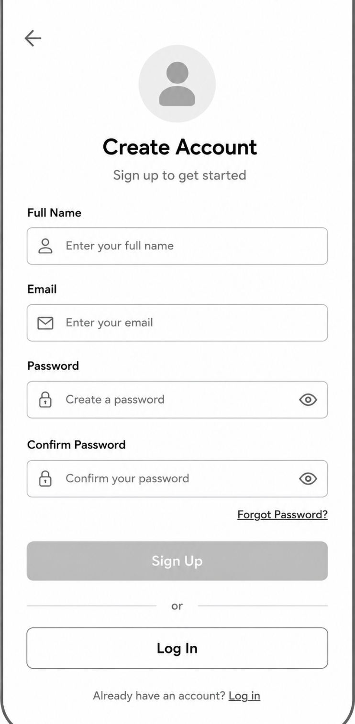

Explaination:

This low-fidelity wireframe is designed for a mobile app login system. The layout includes essential elements such as logo/title, email or username field, password field, login button, forgot password option, and sign-up option. Clear spacing, simple labels, and organized placement make the interface easy to understand and improve the overall user experience.

